Dolgin Expands Battery Charger configuration to include Panasonic VW-VBD58 batteries

Note: as of May 2016 all VW-VBD58 models are discontinued as all standard Panasonic "D54" models have been upgraded to become D54/VW-VBD58 compatible

May 2015

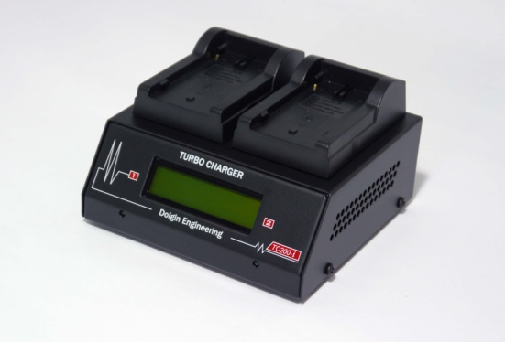
Lexington, MA – Dolgin Engineering, a leading provider of fast multi position battery chargers and DC power adapters announces a new battery charger configuration designed to charge batteries for the newest Panasonic AJ-PX270 camera. Compatible with VW-VBD58 batteries, Dolgin chargers meet the industry’s demand for both two and four position fast charging, with five models now available for immediate delivery.
The Dolgin TC200i, TC40, and TC400 product lines have been expanded to include the latest Panasonic VW-VBD58 battery configuration:

MODEL | USE with batteries/cameras | Description
TC400P58 | VW-VBD58 (Panasonic AJ-PX270)  Compatible with legacy CGR-D54 (Panasonic DVX-100/HVX200/HPX170 ) batteries | This fast four position simultaneous battery charger with diagnostics display accepts Panasonic VW-VBD58 batteries.  Compatible with legacy CGR-D54 (Panasonic DVX-100/HVX200/HPX170 ) batteries.  Compatible with Non-OEM batteries.
TC400P58TDM | VW-VBD58 (Panasonic AJ-PX270)  Compatible with legacy CGR-D54 (Panasonic DVX-100/HVX200/HPX170 ) batteries | This fast four position simultaneous battery charger with diagnostics display accepts Panasonic VW-VBD58 batteries.  Compatible with legacy CGR-D54 (Panasonic DVX-100/HVX200/HPX170 ) batteries.  Compatible with Non-OEM batteries.  Built-In Test / Discharge Module
TC40P58 | VW-VBD58 (Panasonic AJ-PX270)  Compatible with legacy CGR-D54 (Panasonic DVX-100/HVX200/HPX170 ) batteries | Four position simultaneous battery charger accepts VW-VBD58 (Panasonic AJ-PX270) batteries.  Compatible with legacy CGR-D54 (Panasonic DVX-100/HVX200/HPX170 ) batteries.  Compatible with Non-OEM batteries.
TC200P58-I | VW-VBD58 (Panasonic AJ-PX270)  Compatible with legacy CGR-D54 (Panasonic DVX-100/HVX200/HPX170 ) batteries | The TC200P58-I ultra fast two position battery charger accepts VW-VBD58 (Panasonic AJ-PX270) batteries.  Compatible with legacy CGR-D54 (Panasonic DVX-100/HVX200/HPX170 ) batteries.  Compatible with Non-OEM batteries.  USB port for fast charging smart phones and tablets.

TC200P58ITDM | VW-VBD58 (Panasonic AJ-PX270)  Compatible with legacy CGR-D54 (Panasonic DVX-100/HVX200/HPX170 ) batteries | This TC200P58ITDM ultra fast two position battery charger accepts VW-VBD58 (Panasonic AJ-PX270) batteries.  Compatible with legacy CGR-D54 (Panasonic DVX-100/HVX200/HPX170 ) batteries.  Compatible with Non-OEM batteries.  USB port for fast charging smart phones and tablets.  A built-in Test/Discharge Module (TDM)
For more information visit Dolgin Engineering www.dolgin.net or call (781) 863-1813

